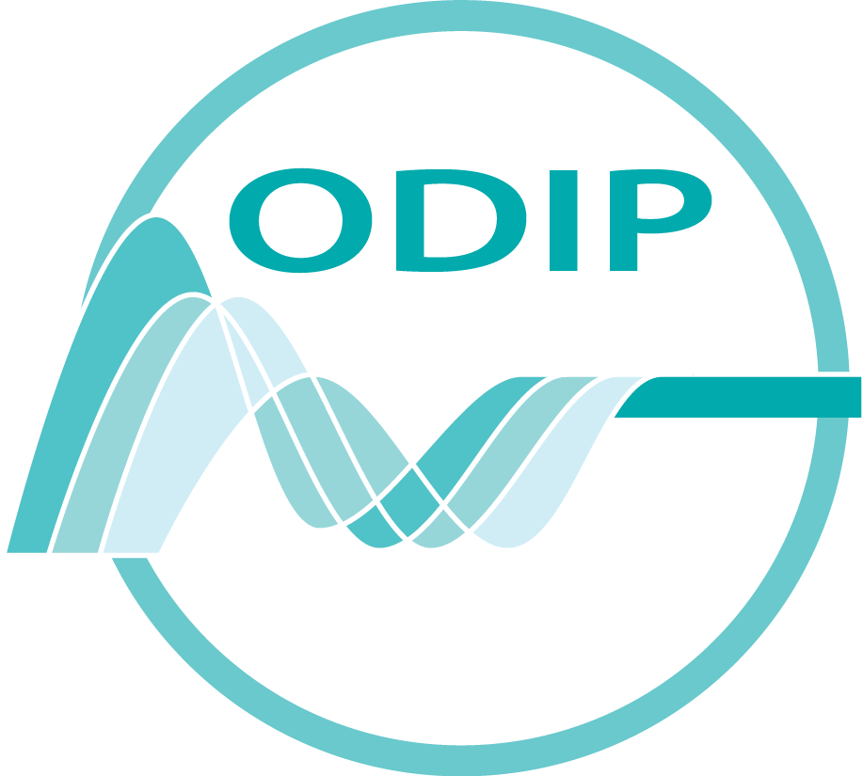
SPM2.2 Ocean Data Interoperability Platform (ODIP)
Splinter Meeting (public)
Thursday, 1 May 15:30 – 17:00

Conveners: Helen Glaves (British Geological Survey) Co-ordinator
Dick Schaap (MARIS) Technical co-ordinator

EGU Room R9 http://www.egu2013.eu/EGU2013_Floor_Plan_Red_Level.pdf

Objective
This meeting is intended to provide an update on progress on the ODIP project and give the wider marine community an opportunity to contribute to discussions regarding priorities for the current project and also for any potential future project proposals. It will also provide those attending this meeting with an opportunity to comment on the outcomes and proposed next steps developed as a result of the recent 2nd ODIP workshop.

This meeting will also allow anyone interested in the ODIP project to engage with colleagues in the project consortium and express an interest in any future opportunities to participate in the project.

Agenda

15:30 – 15:45 Welcome and Introduction Helen Glaves (Co-ordinator)
15:45 – 16:10 Update on project progress and next steps
Dick Schaap (Technical Co-ordinator), Robert Arko &
Roger Proctor

16:10 – 16:25 ODIP collaboration opportunities
Helen Glaves
16:25 – 17:00 Discussion

